**Detailed Design Specification**

1. **Back-end module design notes**
   1. **China map of the average pollution interface by province -getAllProvincePollutions**
      1. **Module description**

Get the six-year average of each pollutant for each province of the China map.

* + 1. **Input**

None

* + 1. **Output**

A list of six-year average values of each pollutant for each province is available.

* + 1. **Algorithm design**

The first step is to calculate the AQI values. The first step is to cross-reference the classification of each pollutant against the the first step is to calculate the air quality index (IAQI) based on the measured concentrations of fine particulate matter (PM2.5), respirable particulate matter (PM10), sulfur dioxide (SO2), nitrogen dioxide (NO2), carbon monoxide (CO), ozone (O3), and other pollutants, respectively, according to the following calculation formula:

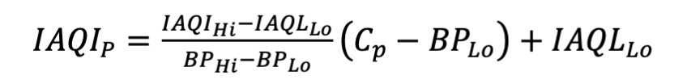

Then take the maximum value of each pollutant air quality sub-index is the air quality number (AQI for short).

Finally, the 6-year average of pollutants in each province is loaded into Pollution object, and finally the map with the mapping relationship between provinces and Pollution object is loaded into list and returned to the front-end.

* 1. **Obtain the average value of pollutants in each province according to the year -getInfoByYear**
     1. **Module description**

Output the average value of pollutants for each province according to the input year.

* + 1. **Input**

Year

* + 1. **Output**

Pollutant averages for each province in the year.

* 1. **Interface to obtain urban pollution data according to the name and year of the province -getCityInfoByProvince**
     1. **Module description**

Obtain urban pollution data by province name and year.

* + 1. **Input**

Province、Year

* + 1. **Output**

Provincial pollutant data in a given year.

* 1. **Obtain the average provincial pollutants in the last six years -** **getSomeAvgCount**
     1. **Module description**

Get six-year national average of all provinces by pollutant.

* + 1. **Input**

None

* + 1. **Output**

Six-year national average of all provinces for each pollutant.

* 1. **Interface for obtaining average urban pollutant values for the target year -** **getSomeCityAvgCount**
     1. **Module description**

Obtain the pressure, temperature and humidity of a city for the last six years.

* + 1. **Input**

City

* + 1. **Output**

The pressure, temperature and humidity of the city for the last six years.

* 1. **Obtain pollutant data for the top ten provinces in the country for the last six years -** **getTenProvinceAsc**
     1. **Module description**

Get the top 10 AQI provinces each year, with other pollutants returned in order of AQI.

* + 1. **Input**

None

* + 1. **Output**

Top 10 AQI provinces per year and the value of each pollutant in that province.

* 1. **Interface to obtain the national average of pollutants for the last six years -getSixAverage**
     1. **Module description**

Get six-year national pollutant averages.

* + 1. **Input**

None

* + 1. **Output**

Six-year average for each pollutant.

* 1. **Obtain the pollutant data of the top ten cities in a province in the last six years -getTenCityAsc**
     1. **Module description**

Get the top 10 city pollutant data for each year in six years for the specified provinces.

* + 1. **Input**

Province

* + 1. **Output**

Get the top ten city pollutant data for the specified province for each of the six years, along with their pollutant values.

* 1. **Get Pollutant Average Data Interface - Get the average pollutant data of a province in the last six years -getSixAverageByProvince**
     1. **Module description**Obtain the average pollutant data of a province for the last six years
     2. **Input**

Province

* + 1. **Output**

The six-year average of each pollutant in the province.

1. **front-end module design description**
   1. **index.vue**



Title (Text): Visualization of Air Pollution

Subtitle (text): Visualization of air quality in provinces and cities across the country

Names of team members (text)

Current date and time (text)

Four modules: left1, center1, center2, and right correspond to left, upper center, lower center, and right, respectively

* 1. **Realistic national and provincial maps and information -left1.vue**

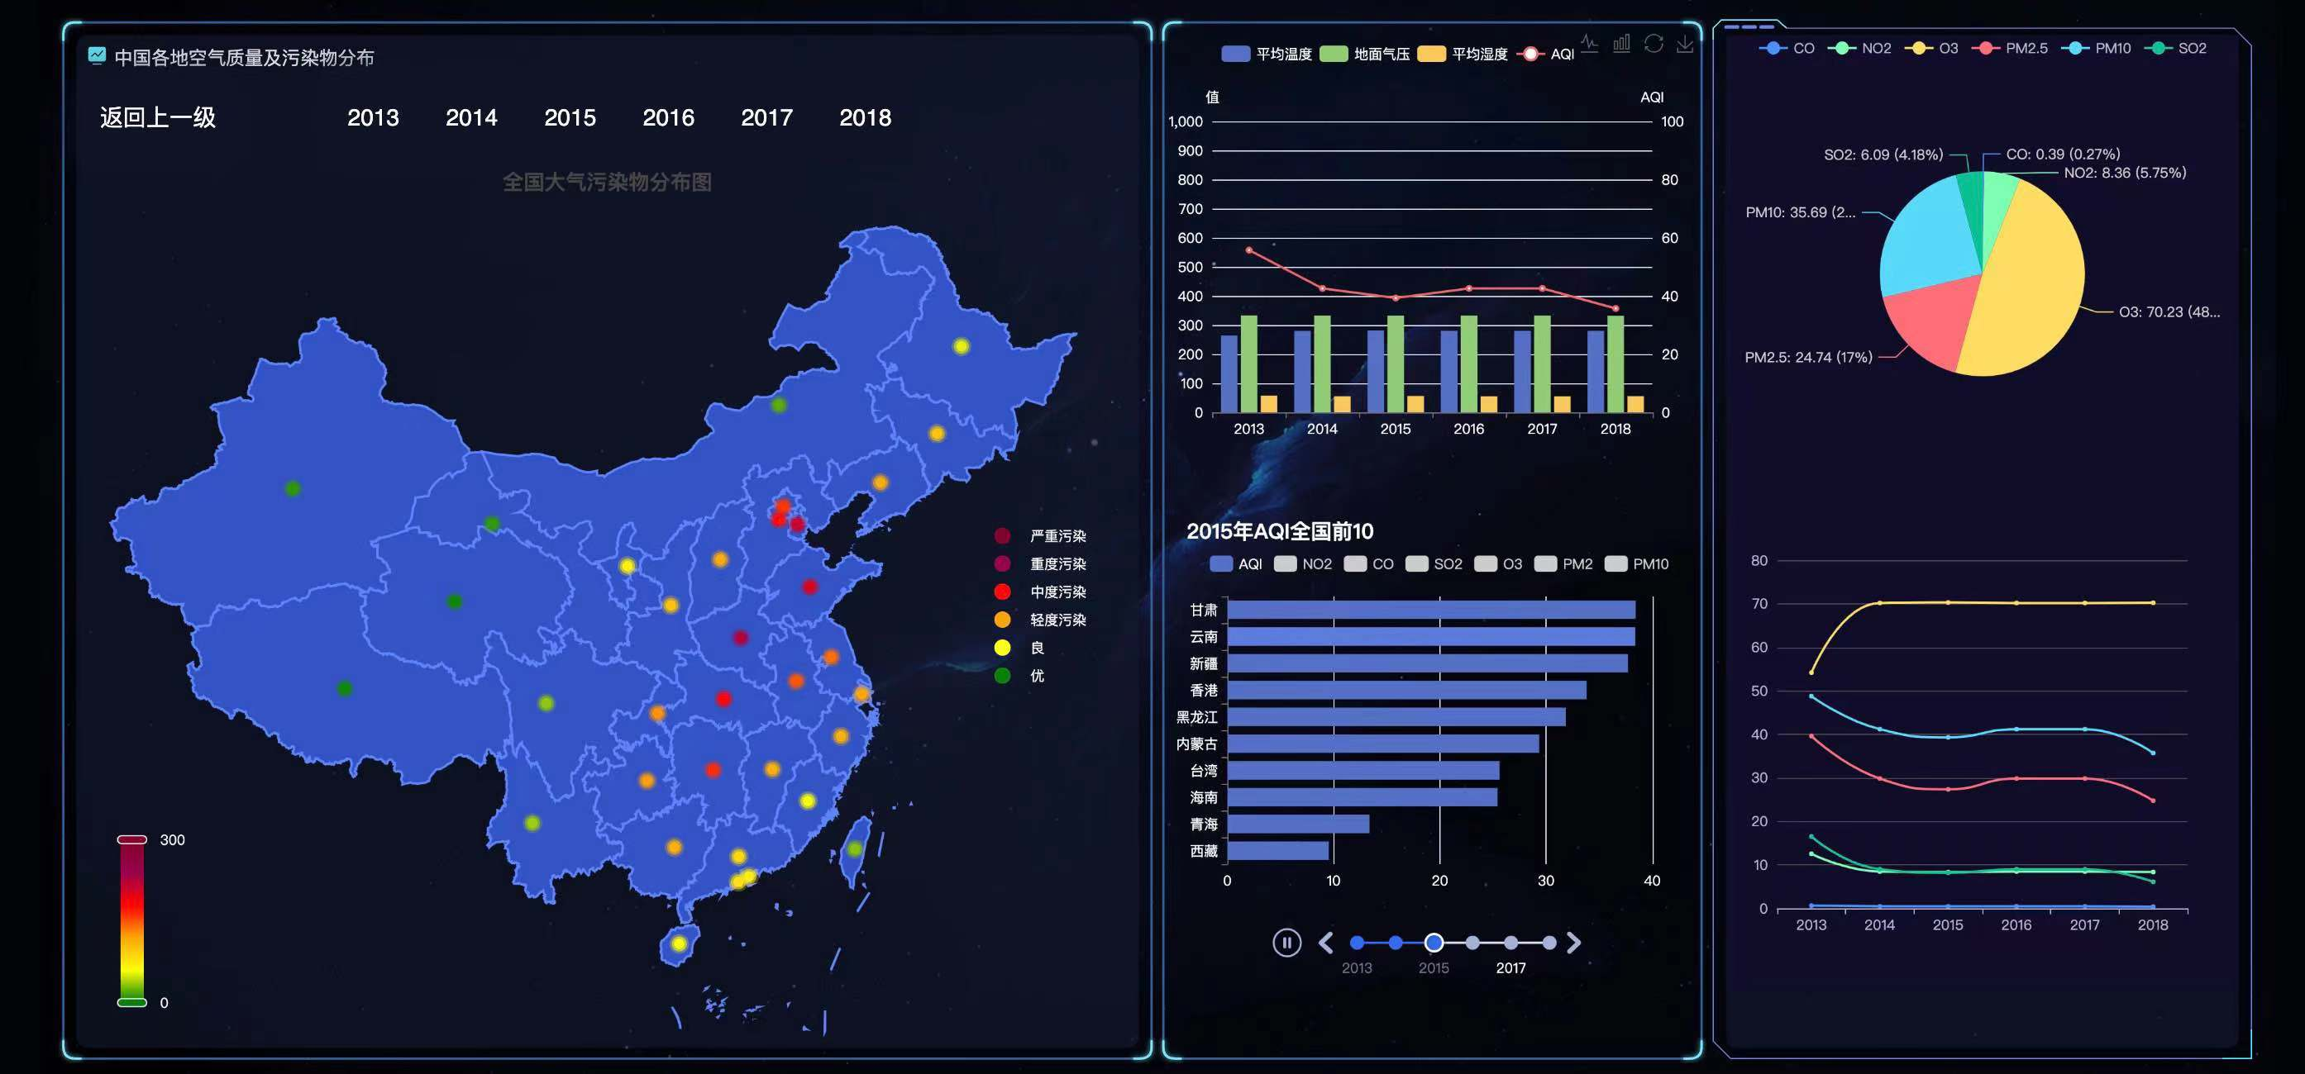

Title (Text):Air quality and pollutant distribution across China

Return to previous level (button):Click to call returnLevel to realize the provincial map drill back to China map

2013~2018 (button): click on 20XX to call getInfoByYear20XX() to view the number of air pollution information of different years

Map: call drawChina to draw a map, register the available maps through echart.registerMap(), set five colors to represent "severe pollution", "heavy pollution", "moderate pollution", "moderate pollution", and "high pollution", "moderate pollution", "light pollution", "good" and "excellent", and set five labels in each province of the map. The location of the provincial capital shows light dots of corresponding colors according to the local air quality condition. By selecting the range on the color spectrum, you can display only the light dots of certain provinces, and mouse over a certain identity will show the specific information of that province.

Province: When clicking on a province, call getDown() to drill down, all pages will display the air pollution data information of this province, when clicking on provinces as Shanghai, Beijing, Chongqing, Tianjin, Hong Kong SAR, Macau SAR and Taiwan Province, no drill down operation will be performed, after the drill down, data information of cities in the province will be displayed. The following is the effect of drilling down after clicking on Inner Mongolia Autonomous Region:

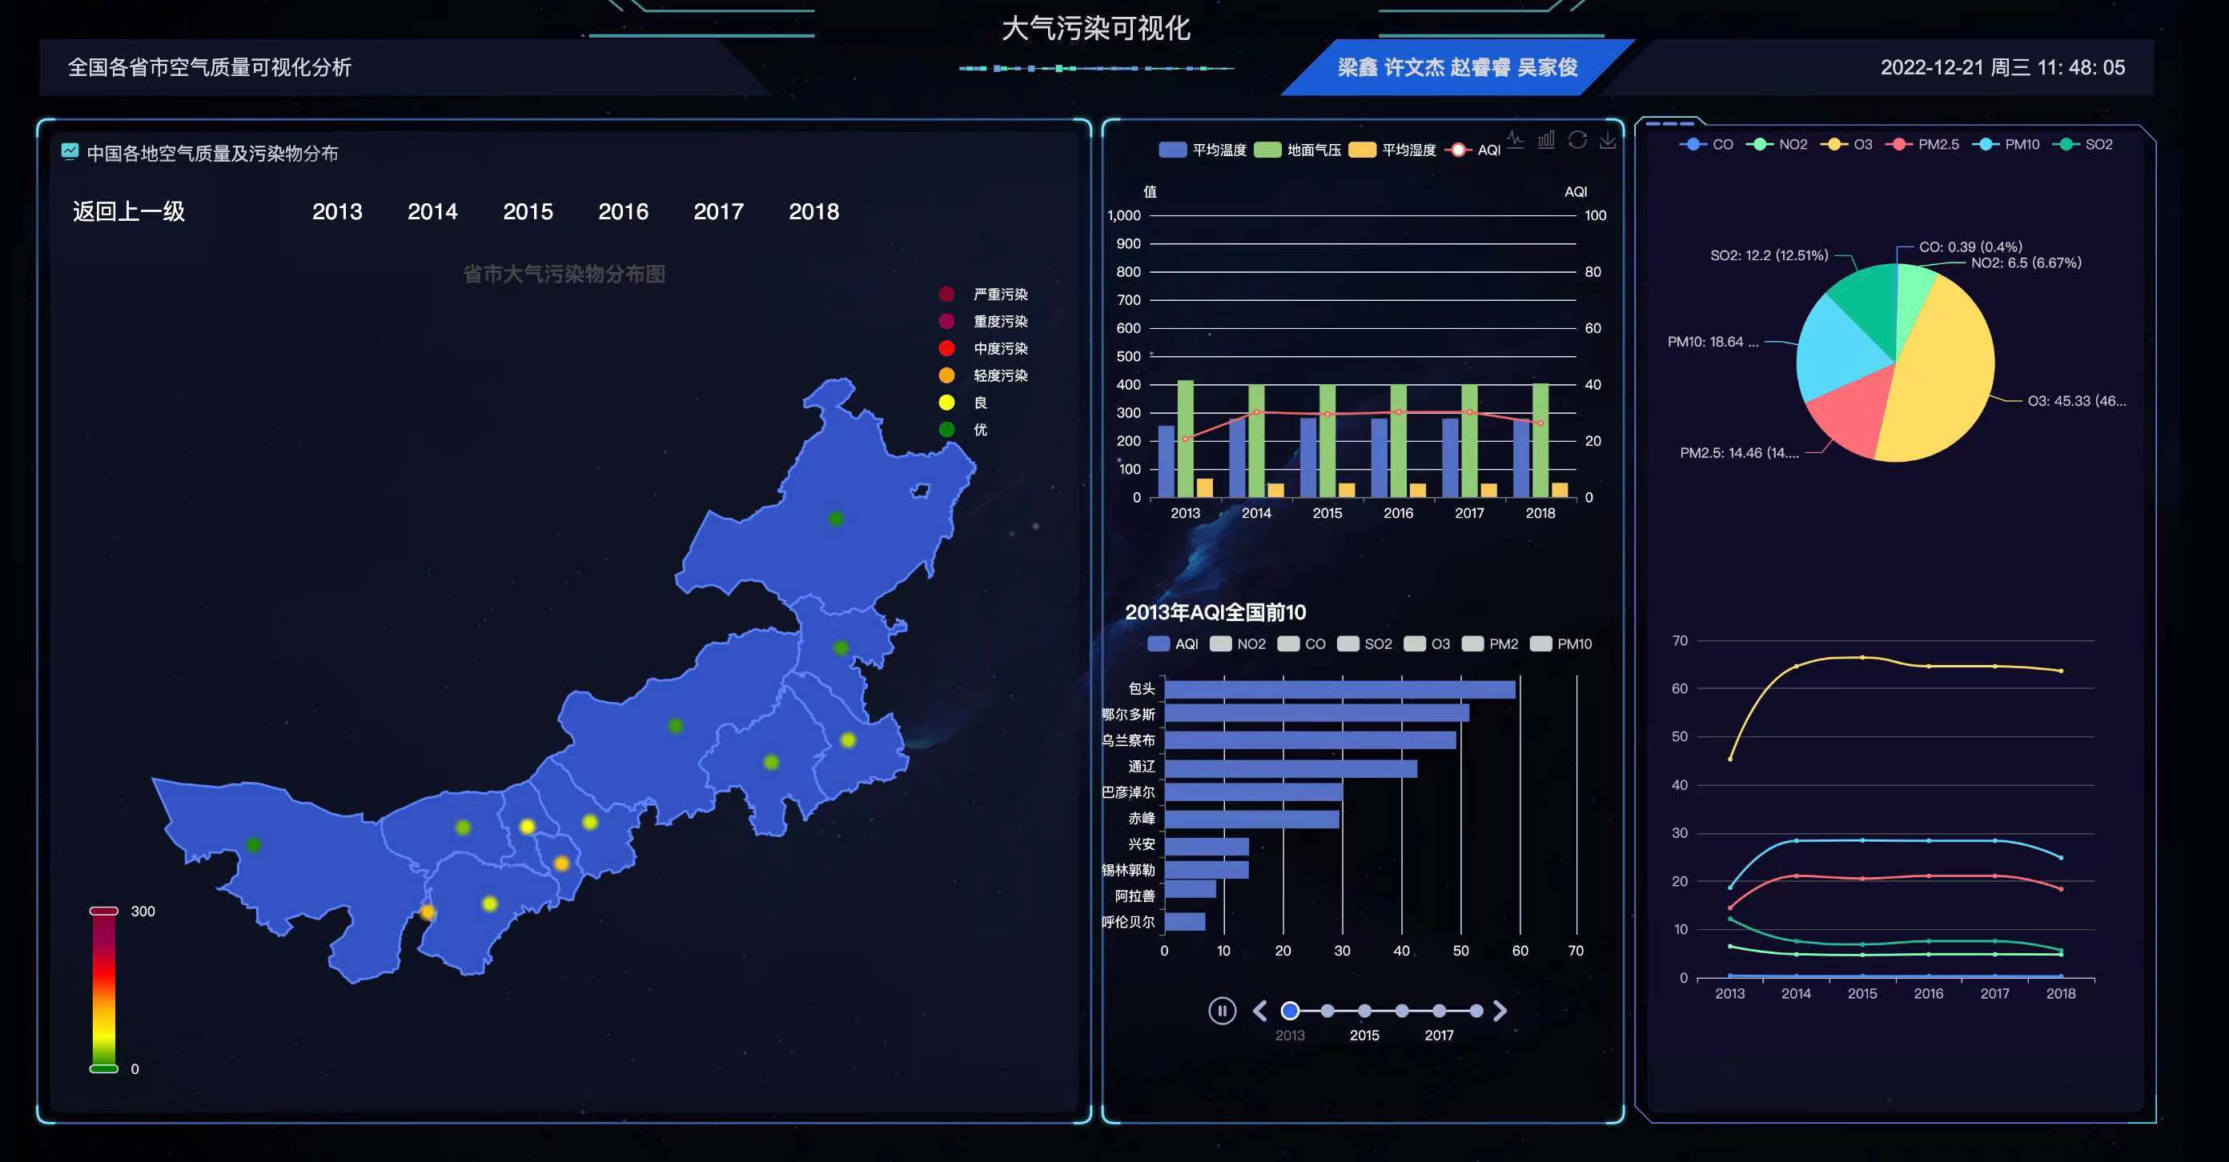

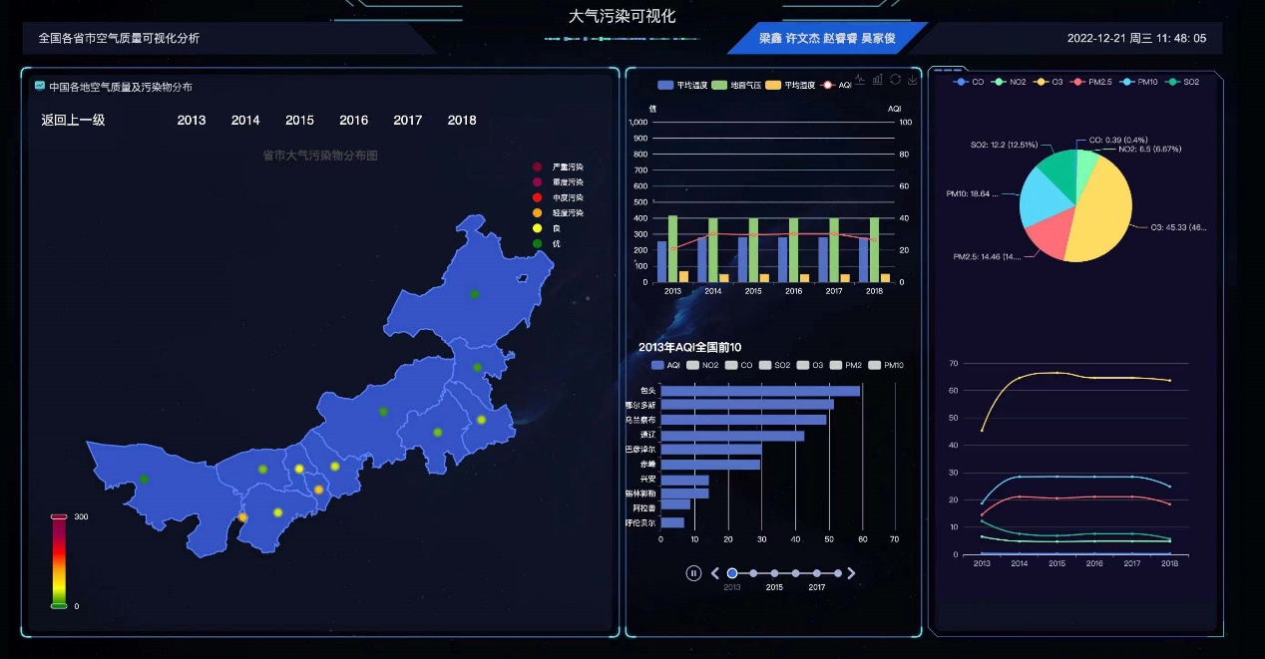

* 1. **Relationship between AQI and mean temperature, ground pressure, and mean humidity over the six-year period -center1.vue**

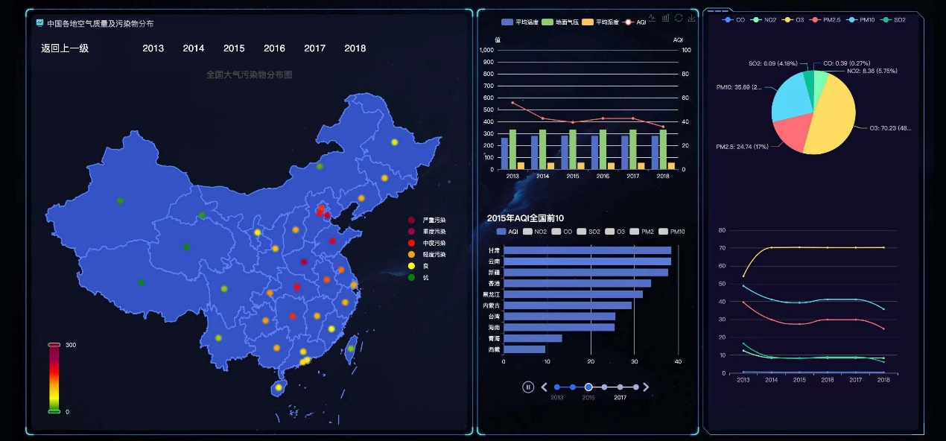

Air quality analysis bar chart: the horizontal coordinate is 2013~2018, the vertical coordinate is the value, call getData to get the data information, display the four fold lines of average temperature, ground pressure, average humidity, and AQI.

Average temperature, ground pressure, average humidity, AQI (button): you can choose to hide or show the fold after clicking.

* 1. **Top 10 provinces (cities) with the smallest AQI values nationwide according to AQI order 2013-2018 -center2.vue**



Title: 20XX AQI National Top 10

Timeline: 2013~2018, each year corresponds to a bar chart

AQI ranking bar chart: the vertical coordinate is the name of the top ten provinces and cities, the horizontal coordinate is the value, call getAqiByAsc() in getData to get the data and sort them, dataFormatterNO2(), dataFormatterCO(), dataFormatterSO2(), dataFormatterPM2(), dataFormatterPM10() to get the data of NO2, CO, SO2, O3, PM2.5 and PM10 respectively, dataFormatterO3(), dataFormatterPM2(), dataFormatterPM10() to get the data of NO2, CO, SO2, O3, PM2.5 and PM10 respectively.

CO, NO2, O3, PM2.5, PM10, SO2 (button): you can choose to hide or show this histogram after clicking

* 1. **Trends in the mean values and percentages of pollutant components over 6 years -right1.vue**



Pollutant average line graph: the horizontal coordinate is the year, the vertical coordinate is the value, get data by getData, display the average value of CO, NO2, O3, PM2.5, PM10, SO2 for the whole country or a province, where the six lines and the pie chart are combined into one component, when the year changes, the pie chart will change together with the line graph.

CO, NO2, O3, PM2.5, PM10, SO2 (button): you can choose to hide or show the information of this component when you click on it.

Pollutant share sector chart: Show the information of pollutant component share for China or a province.

1. **Database design**

|  |  |  |  |  |  |  |
| --- | --- | --- | --- | --- | --- | --- |
| No. | Field Name | Type | Length | Null | PK | Description |
| 1 | id | int |  | No | Yes | id |
| 2 | pm2 | decimal | 20 | No | No | PM2.5 |
| 3 | pm10 | decimal | 20 | No | No | PM10 |
| 4 | so2 | decimal | 20 | No | No | SO2 |
| 5 | no2 | decimal | 20 | No | No | NO2 |
| 6 | co | decimal | 20 | No | No | CO |
| 7 | o3 | decimal | 20 | No | No | O3 |
| 10 | temp | decimal | 20 | No | No | 温度 |
| 11 | rh | decimal | 20 | No | No | 相对湿度 |
| 12 | psfc | decimal | 20 | No | No | 地面气压 |
| 13 | lat | decimal | 20 | No | No | 中心纬度 |
| 14 | lon | decimal | 20 | No | No | 中心经度 |
| 15 | aqi | decimal | 20 | Yes | No | 空气质量指数 |
| 16 | province | varchar | 255 | Yes | No | 省 |
| 17 | city | varchar | 255 | Yes | No | 市 |
| 18 | monnth | int |  | No | No | 月份 |